LUNCH
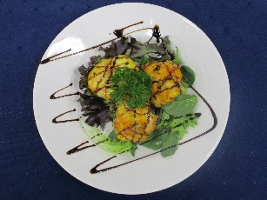

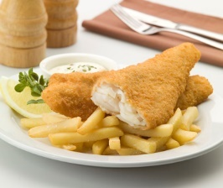

Stuffed Mushrooms

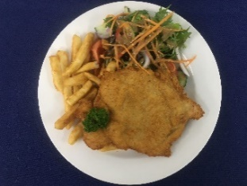

Crumbed Fish

Chicken Schnitzel
Starters
GARLIC BREAD (GF Option) $6.00

CHEESY GARLIC BREAD (GF Option) $7.00

THAI SPRING ROLLS $9.00
FILLED WITH PORK. NOODLES & VEGETABLES
WITH A SWEET CHILLI SAUCE

S & P CALAMARI $10.50
SERVED WITH WOMBOK SALAD & GARLIC AIOLI

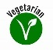
STUFFED MUSHROOMS $9.50
ROASTED, STUFFED WITH CHEESE, GARLIC, ONION
& CARROT ON A BED OF SALAD LEAVES

BOWL BEER BATTERED CHIPS (S) $4.50
(L) $6.50

Mains
SMALL RUMP STEAK (200grm approx.) $20.00
SERVED WITH YOUR CHOICE OF SAUCE, CHIPS & SALAD
OR VEGETABLES

FISH (CRUMBED) $15.50
SERVED WITH CHIPS & SALAD

CHICKEN SCHNITZEL $14.50
SERVED WITH CHIPS & SALAD

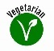
FALAFEL WRAP $12.50
SERVED WITH CHIPS

CHICKEN PARMIGIANA $21.00
FRESHLY CRUMBED BREAST, TOPPED WITH HOMEMADE
NAPOLI SAUCES AND MELTED CHEESE, SERVED WITH CHIPS
& SALAD OR VEGETABLES

Sandwiches – Fresh & Toasted (GF option available)
HAM AND CHEESE $5.50

HAM CHEESE TOMATO $6.00

CHICKEN AND CHEESE $5.50

CHEESE AND TOMATO $4.50

CHICKEN, CHEESE AND TOMATO $6.00

Kids
CHICKEN NUGGETS & CHIPS $10.00

SPAGHETTI BOLOGNAISE $10.00

ALL KIDS MEALS INCLUDE ICE-CREAM AND TOPPING

FOOD ALLERGIES
Please be aware that all care is taken when catering for special requirements. It must be noted that within the premises we handle nuts, seafood, shellfish, sesame seeds, wheat flour, eggs, fungi & dairy products. Customer requests will be catered for to the best of our ability, but the decision to consume a meal is the responsibility of the diner.

DINNER

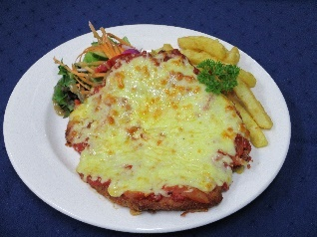

Stuffed Mushrooms

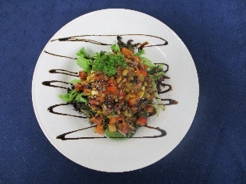

Chicken Parmigiana

Halloumi Stack

Starters
GARLIC BREAD (GF Option) $6.00

CHEESY GARLIC BREAD (GF Option) $7.00

THAI SPRING ROLLS $9.00
FILLED WITH PORK. NOODLES & VEGETABLES
WITH A SWEET CHILLI SAUCE

S & P CALAMARI $10.50
SERVED WITH WOMBOK SALAD & GARLIC AIOLI

STUFFED MUSHROOMS $9.50
ROASTED, STUFFED WITH CHEESE, GARLIC, ONION
& CARROT ON A BED OF SALAD LEAVES

BOWL BEER BATTERED CHIPS (S) $4.50
(L) $6.50

Mains
GRILLED BARRAMUNDI $21.00
SERVED WITH CHIPS & SALAD OR SEASONAL VEGETABLES

HALLOUMI STACK $18.00
HOMEMADE CORN FRITTERS SERVED WITH GRILLED HALLOUMI,
AVOCADO AND SALSA ON A BED OF MESCULIN

LOADED NACHOS $16.00
CORN CHIPS TOPPED WITH CHILLI MINCE, BEAN SALSA &
MELTED CHEESE, SERVED WITH SOUR CREAM (VEGETARIAN
OPTION AVAILABLE)
ADD AVOCADO EXTRA $2.00

CHICKEN BACON AND MUSHROOM $20.00
PAN FRIED CHICKEN BREAST WITH A CREAMY BACON AND
MUSHROOM SAUCE SERVED WITH CHIPS & SALAD OR VEGETABLES

CHICKEN CARBONARA $17.00
CHICKEN, BACON AND PARMESAN CHEESE IN A CREAMY SAUCE TOSSED THROUGH SPAGHETTI

Steaks and Chicken
300grm RUMP (APPROX) $29.50

250grm RIB FILLET (APPROX) $31.50
ALL STEAKS SERVED WITH CHOICE OF SAUCE, CHIPS & SALAD
OR VEGETABLES

CHICKEN SCHNITZEL $19.50
FRESHLY CRUMBED BREAST SERVED WITH CHIPS
& SALAD OR VEGETABLES

CHICKEN PARMIGIANA $21.00
FRESHLY CRUMBED BREAST, TOPPED WITH HOMEMADE
NAPOLI SAUCES AND MELTED CHEESE, SERVED WITH CHIPS
& SALAD OR VEGETABLES

Kids
CHICKEN NUGGETS & CHIPS $10.00

SPAGHETTI BOLOGNAISE $10.00

ALL KIDS MEALS INCLUDE ICE-CREAM AND TOPPING

FOOD ALLERGIES
Please be aware that all care is taken when catering for special requirements. It must be noted that within the premises we handle nuts, seafood, shellfish, sesame seeds, wheat flour, eggs, fungi & dairy products. Customer requests will be catered for to the best of our ability, but the decision to consume a meal is the responsibility of the diner.

